Understanding Under-fitting and Over-fitting in Decision Trees

The Role of Tree Depth

1. Introduction

The patterns learned by machine learning models are used as the foundation for making predictions. The question that now emerges is how does a model make a decision?

Decision Tree is by far the easiest machine learning algorithm to understand. Most people are familiar with Decision Trees because they're used so frequently. Decision Trees can be used to easily solve hard decision problems. Conceptually, Decision Trees work via a flowchart. Each node in the tree is a question that we want our data to answer. The path that tree takes is determined by the answer provided by the data.

For example, in the case of medical data, the machine learning model could use its decision tree to classify a tumor as either benign or malignant by asking different questions based on the characteristics of the tumor. This makes the Decision Tree easily understandable for anyone.

However, one major problem with the Decision Tree is the problem of overfitting. Overfitting is the problem that occurs when the machine learning model becomes so specialized with the data that it performs poorly with other data. The focus of this tutorial is the importance of the depth of the tree in the Decision Tree.

2. Dataset Used
In the current study, the Breast Cancer Wisconsin data set was used, which is commonly used for classification problems. The data set contains features based on images of breast masses. The goal is to classify the tumors as:
  - Benign (non-cancerous)
  - Malignant (cancerous)
We can easily access the data set with the help of sklearn which is a python library. This library allows us to use the data set easily.

3. What is a Decision Tree?
A decision tree represents a supervised learning approach that is utilized for classification. It works by dividing the data into smaller sets based on given conditions. All the elements of the tree have unique roles:
- Root Node: It is the starting point of the tree
- Decision Nodes: These are the points where data is split
- Leaf Nodes: These are the points where prediction takes place
The data is split based on the best feature and the corresponding threshold at each stage. This continues until the termination conditions are met. The result is a representation of the decisions made in the form of a tree-like data structure.

4. Understanding Tree Depth
Tree depth refers to how many levels are in the decision tree. This starts at the root node and ends at the leaf node. The tree's depth is equivalent to how many steps occur before reaching your final decision.
Shallow trees have fewer levels, which result in a low number of decisions, whereas deeper trees allow for a higher degree of decision-making.
- Depth = 1 → very simple tree
- Higher depth → more complex tree

Tree depth is used to determine the level of complexity the model can achieve.

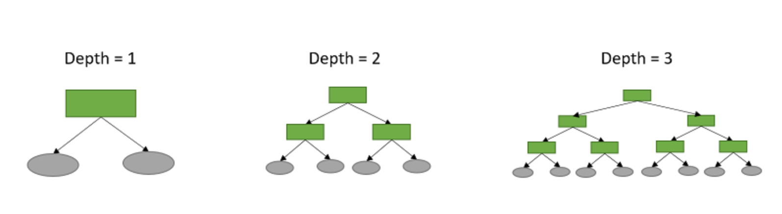

Source: https://statlect.com/machine-learning/decision-tree

Why Depth Matters
- Low depth:
  - Few splits are performed
  - The model is too simple
  - Important patterns can be missed (underfitting)
- High depth:
  - Many splits are performed
  - The tree is very complex
  - Risk of overfitting (memorization of the data) is high
We want to figure out which depth leads to the best performance on new data.

5. Under-fitting vs Over-fitting

Under-fitting
Under-fitting occurs when a model is too simple in relation to the underlying data-generating process.
For example, a simple decision tree may not be able to sufficiently divide the data and therefore may not perform well in its predictive capabilities.
Indicators include low training accuracy and low test accuracy.

Over-fitting
Over-fitting occurs when a model becomes too complex and begins to learn noise in the data.
For example, a deep decision tree may continue to divide until it has a near-perfect fit to the training data.
Indicators include high training accuracy and stagnant test accuracy.

Goal
The aim is to discover the best tree depth, which, on the one hand, is sufficiently deep to uncover important patterns, and on the other hand, does not become so deep that the model starts over-fitting the training set.

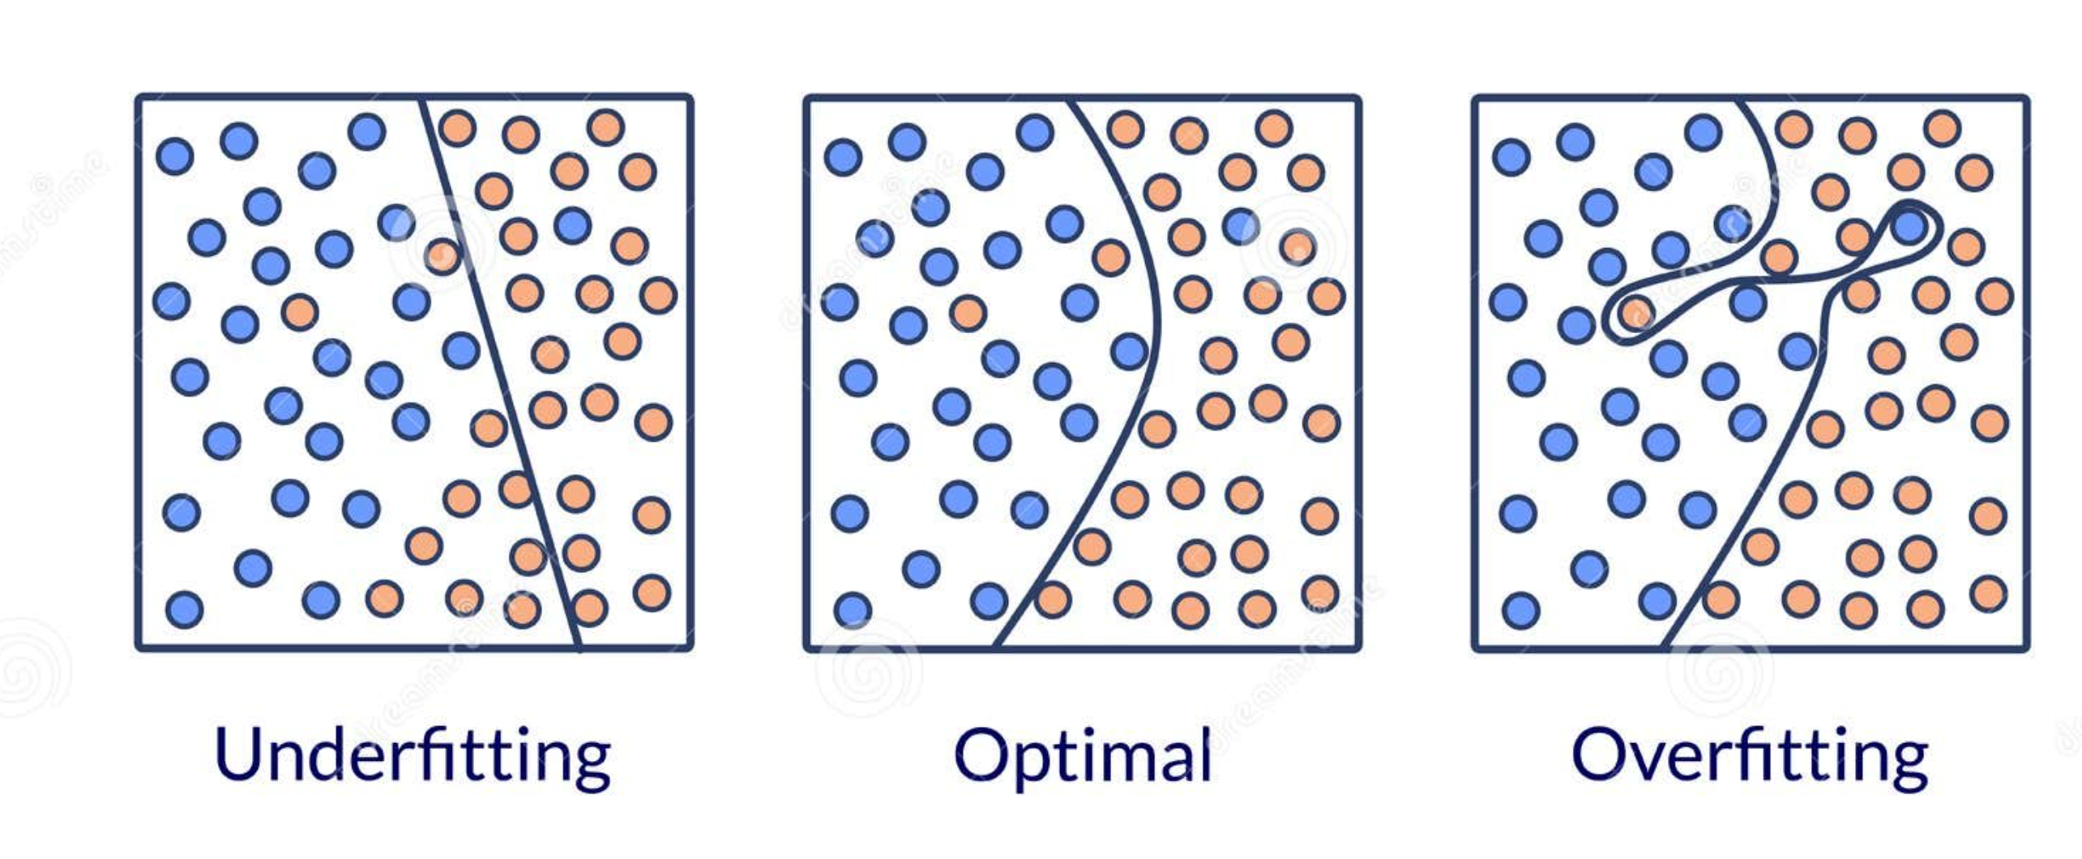

6. Experiment: Effect of Tree Depth
To understand the impact of tree depth on the performance of a decision tree, an experiment is performed on the Breast Cancer Wisconsin dataset.

Steps for the experiment:

- Load the dataset
- Split the data into subsets for training and testing
- Train decision tree models with different depths: 1, 3, 5, and 10
- Evaluation criteria: Training Accuracy and Testing Accuracy

All the above steps are implemented in the attached notebook which needs to be executed in order to get the plots and results shown in this tutorial.

7. Results: Accuracy vs Tree Depth
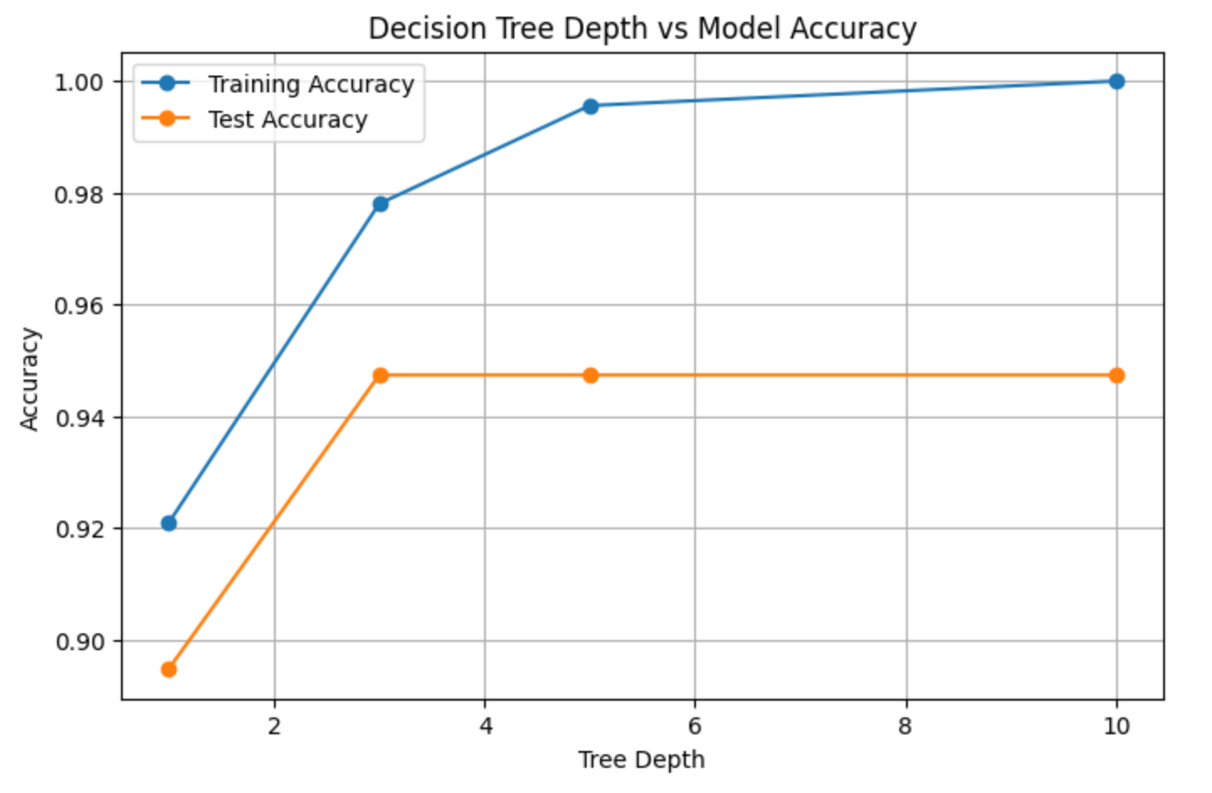

The plot shows the relationship between the training accuracy and the testing accuracy as the depth of the decision tree is increased.

Explanation of Results

Depth = 1
Both training and test accuracy are low, and this is a natural result for an overly simple model, which is undergoing underfitting.

Depth = 3
The training and test accuracy both improve, reflecting a model that is picking up useful trends. This is a near-optimal depth for the model.

Depth = 5
The training accuracy increases, but this is not true for the test accuracy, and this is a result of an overly complex model.

Depth = 10
While the training accuracy is high, test accuracy does not increase. This is an indication of over-fitting.

Key Insight

From the figure above, the following can be noted:
- Increasing the depth of the decision trees always increases the training accuracy.
- Increasing the depth of the decision trees increases the testing accuracy only up to a certain point.

After this point, increasing the depth results in over-fitting. This is one of the basic concepts that are used in machine learning. The complexity of the model that is used is not necessarily reflected in its ability to perform better. The aim is to create a model that can generalize.

8. Decision Tree Visualization
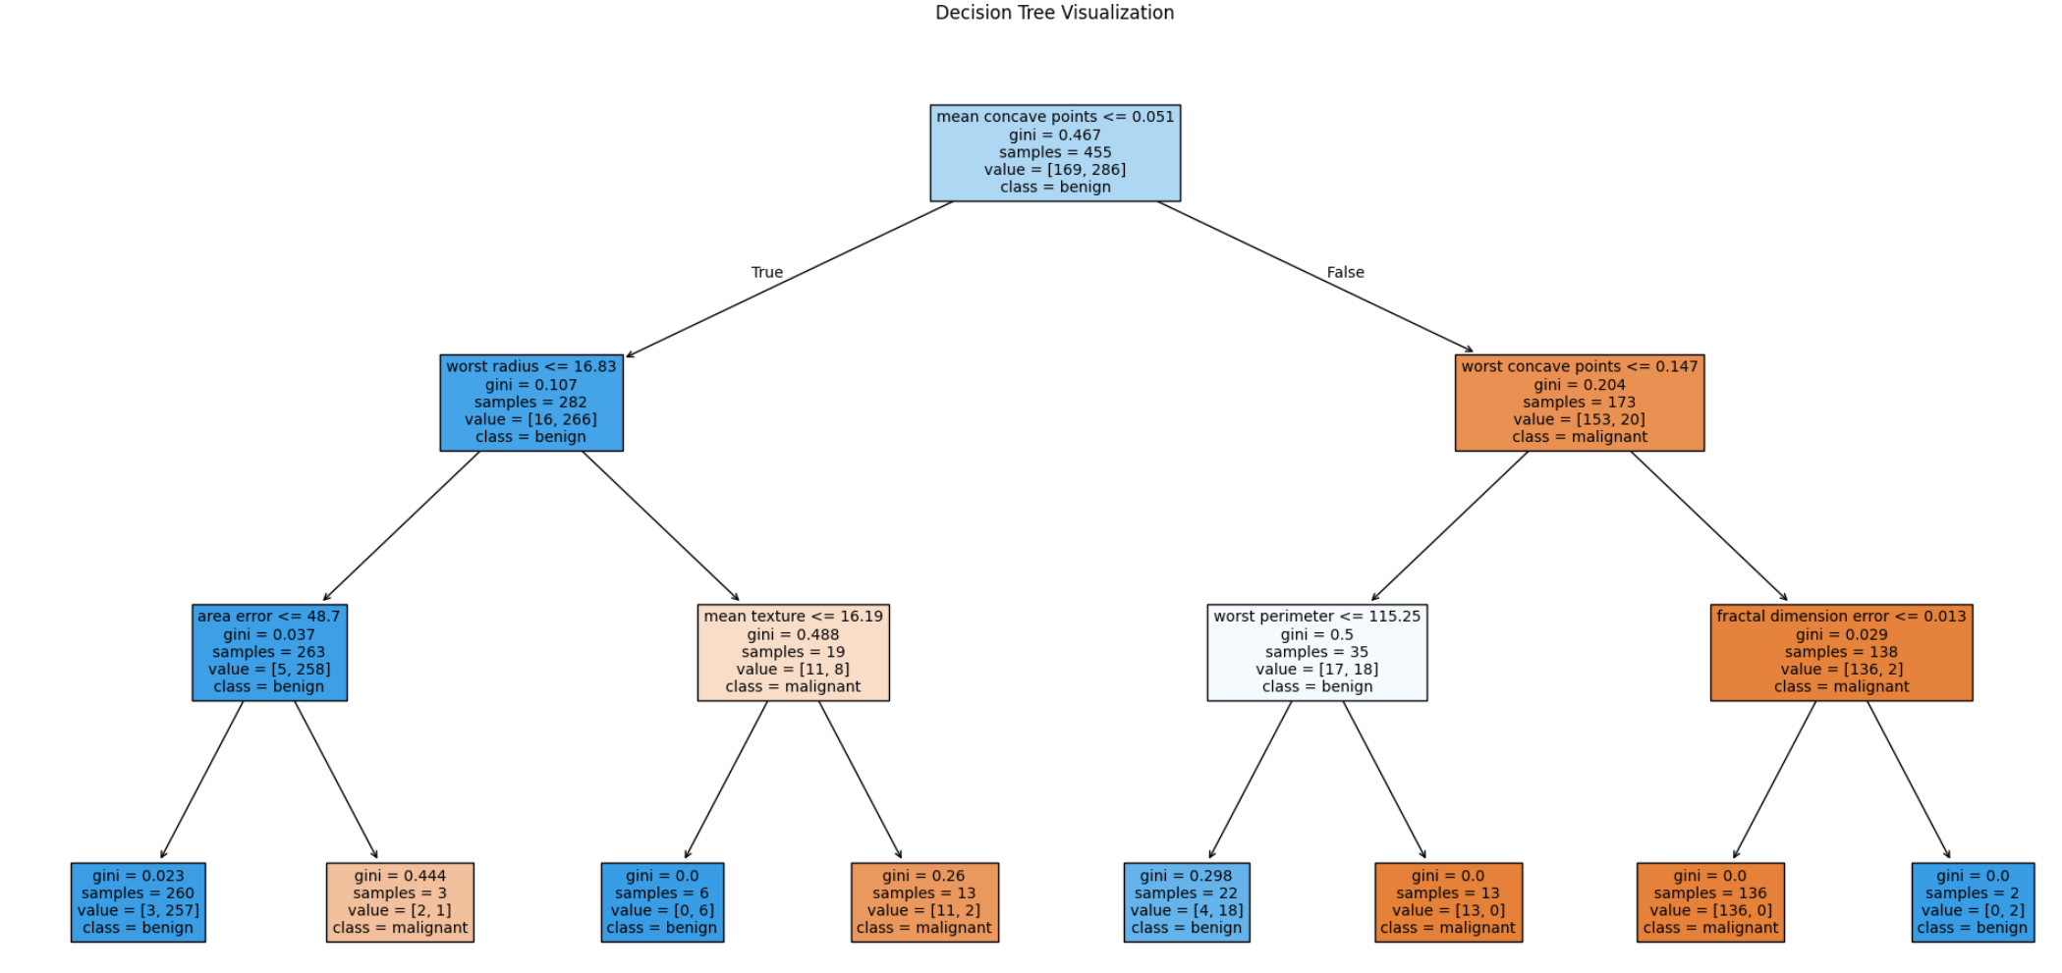

The above decision tree diagram shows how the decision is made for dividing the data for prediction. Although it looks complex, it becomes easy to understand its work by choosing one node.
How to Read the Tree

Each box in the decision tree represents a node. Each node represents a decision. For any given node in the decision tree, it is possible to observe the following:
- A condition (feature, etc.)
- The number of samples reaching the node
- The distribution of classes (benign, malignant, etc.)
- The predicted class

The model starts by making decisions from the root node downwards.

Step-by-Step Decision Process

At a given node,
- A condition is checked by the model (feature <= value)
- If the condition is true, it moves to the left branch
- If condition is false, it moves to the right branch
The process keeps going until it reaches a leaf node and then it is able to make a prediction.

Relation to Depth
The depth of the tree shows the number of decisions that have been made in it. If the depth of the tree is less, this means that the number of levels and the number of decisions are less. On the other hand, if the depth of the tree is more, this implies that the number of levels and the number of decisions are more. Each level of depth adds another condition meaning more complexity.
Why Deeper Trees Become Complex
As the tree becomes deeper, more splits are created. The data are split into more specific sub-groups. The decision rules are more refined. The more depth a tree is, the more it can learn from the data. The more depth, however, increases the risk of over-fitting because more emphasis is placed on detail.
Key Observation

The visualization indicates that decisions are generated successively. The more depth, the more decisions are generated but more complexity. This is why more depth can lead to better performance but little generalization.

9. Key Learnings
The main conclusion that this tutorial has is that the depth of a tree greatly affects the performance of a decision tree.
- A tree with less depth may not be enough to capture all the patterns, leading to under-fitting.
- If the depth of the tree is more, this means that the tree may be too complex, making the data over-fitted.
- Increasing the depth of the tree makes the learning process better but only to a certain degree.

10. Conclusion

The above tutorial discussed how decision trees make their predictions and how their performance is affected by their depth. The results of the experiments showed that increasing depth improves accuracy but does not necessarily improve performance on new, unseen data.

The above results demonstrate a fundamental concept of machine learning. A model should be able to perform well on new data that has not been seen, not just the data used during the training process. If the depth of the tree is less, this may imply that the tree may be under-fitting. On the other hand, if the depth of the tree is more that means the tree may be over-fitting. That’s why it is very important for decision tree models to find the right depth. The balance of simplicity and complexity is a fundamental consideration in many machine learning applications.

11. References
The following resources were used to understand and prepare this tutorial:
- Scikit-learn. Decision Trees.
https://scikit-learn.org/stable/modules/tree.html
- Comprehensive introduction to Decision Trees by Isshin Inada.
https://www.skytowner.com/explore/comprehensive_introduction_to_decision_trees
- Breast Cancer Wisconsin Diagnostic Dataset. https://archive.ics.uci.edu/dataset/17/breast+cancer+wisconsin+diagnostic
- James, G., Witten, D., Hastie, T., Tibshirani, R. (2013). An Introduction to Statistical Learning (Book Chapter 8) Tree-Based Methods.
https://www.statlearning.com/
- Decision Trees Clearly Explained in a video.
https://www.youtube.com/watch?v=7VeUPuFGJHk
- University Lecture Materials. Machine Learning and Neural Networks Module. University of Hertfordshire.

